Lab Creation Guide:
Lab Name: OWASP Juice Factory
Created by: Nilarjo Mazumdar
Platform used: Kali Linux 2025.3
Application used to run the Virtual Machine: VMware Workstation
VM Specifications: Memory- 2GB
Space: 80 GB
Prerequisites:
To run Docker on Windows, the following are the prerequisites:
- Windows 10 or 11
- At least a 64-bit system
- 4 GB RAM
To run Docker on a Linux Virtual Machine, the following are the prerequisites:
- VMware Workstation, Oracle VirtualBox or any other application capable of running a virtual machine.
- At least 2 GB of RAM and 50 GB of storage.
Instructions on how to deploy the lab:
- To do this lab, the basic requirements are to have a machine capable of running Docker or a machine on which Azure Cloud Services can be accessed.
- Running the lab on Docker is the easiest way, and that is shown below.
- I have used Kali Linux to run Docker, but Docker can be executed on Windows too.

- The first step is to install Docker:
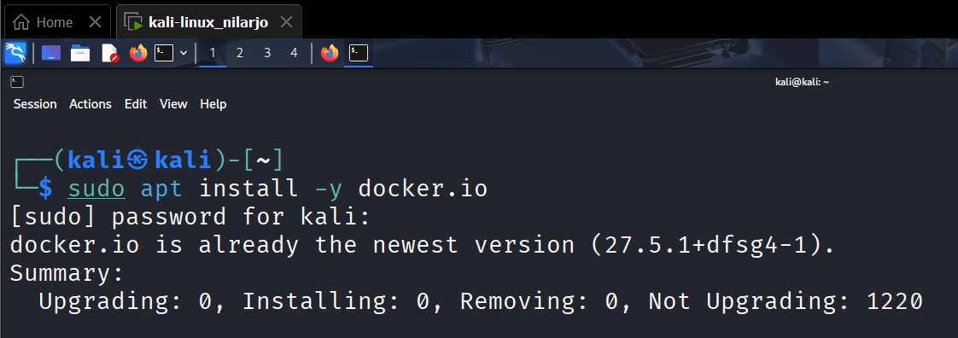
- Start and enable the service
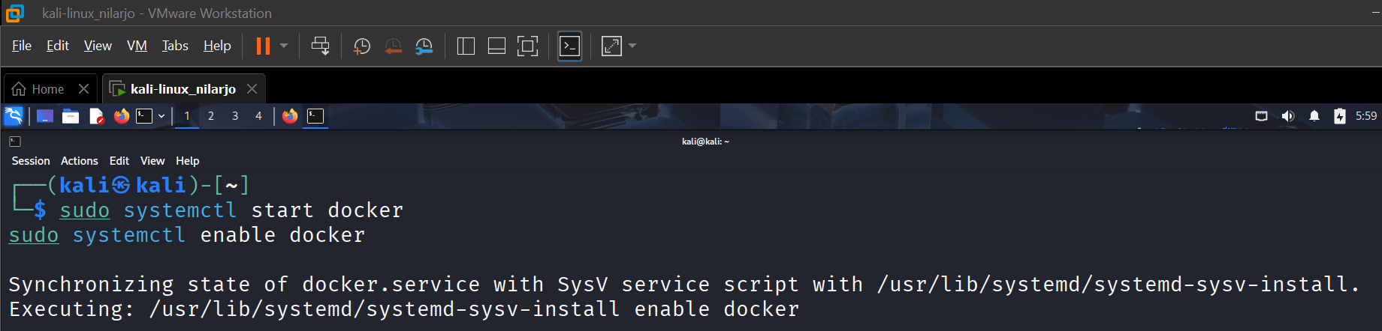
- Docker should be running

- Next step is to pull the exercise from GitHub and bind to a port on the localhost. Here I have used port 3000.
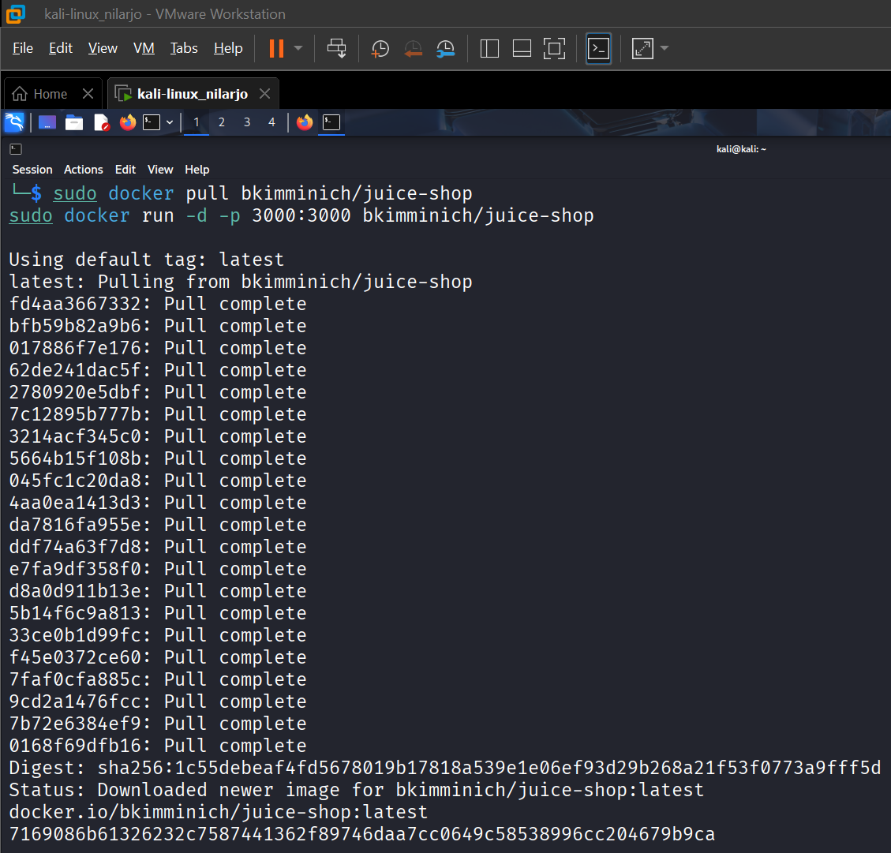
- The OWASP Juice Factory can now be accessed on:
http://localhost:3000/#/

